This worksheet is designed to support teams in brainstorming a list of potential symptoms and root causes for problems in their system. It supports analyzing and developing a shared understanding of the problem. This tool may be used in isolation, or as part of a deeper root cause analysis investigation.

Logistics

Roles: Facilitator, timekeeper, and notetaker (optional)
Size: 3-5 people
Time: 20-30 min
Materials

In-person: Large poster paper, markers, and sticky notes.
Virtual: Shared workspace, such as Google Jamboard.

Instructions for Use

- Introduce the suspected or known problem area.

- Invite meeting participants to independently brainstorm a list of related problems.

- Share out trees. Note similarities and key differences. **Equity pause**

- Create one shared tree that reflects group consensus.

- Develop an action plan to investigate these suspected causes.

- (Optional) Update your tree as you refine your understanding of the problem.

Equity Pause:
1. Who is at the table? Who is missing?
2. How might our current processes/practices/beliefs be contributing to inequity?
3. Embrace “We, not They.” Focus on what YOU can change.

Note: This practice gets our mental models on the table. It does not mean we now know the root cause, but it does direct our attention towards what to probe and investigate.

Brainstorming Space
Problem Area: Click to enter your problem area here
Please see page 2 to map related suspected problems or symptoms.
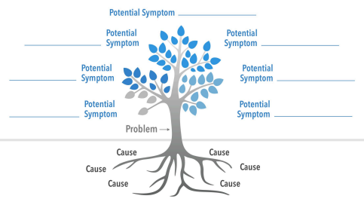
Enter Text here
Enter Text here
Enter Text here
Enter Text here
Enter Text here

Enter Text here
Enter Text here

Key Takeaways
1. Enter text here.
2. Enter text here.
3. Enter text here.
Lingering Questions
1. Enter text here.
2. Enter text here.
3. Enter text here.
Action Plan: Investigate the Problem
1. Enter text here.
2. Enter text here.
3. Enter text here.

